**Contents**

**I Introduction of Snowball Products 2**

1.Introduction to snowball 2

2. Analysis on revenue structure of snowball products 2

3. Introduction to the advantage of snowball products 4

**II Introduction and Principle of Monte Carlo Simulation 5**

1. Procedures of Monte Carlo Simulation 5

2. Application of Monte Carlo Simulation in finance 5

**Ⅲ Snowball Products Pricing and Revenue Measurement 6**

1. Determining parameters 6

2. Simulation of stock index price based on Monte Carlo 9

3. Snowball option pricing 11

4. Revenue measurement of snowball products 11

**IV Analysis on the Final Revenue and Risks of Snowball Products under Different Simulation paths 12**

1. Revenue and risks when only volatility changes 12

2. Revenue and risks when only knock-out price changes. 15

3. Revenue and risks when only knock-in price changes. 17

**Ⅴ Conclusion of Experimental Simulations 18**

**VI Snowball Products and Quota Selection 19**

1. A comparative study on the revenue and risks of "Light of Hope"/"Star Sea" 19

2. Quota selection: 1000 yuan 19

**Ⅶ Algorithm Optimization 20**

1. Optimization of random generation sequences 20

2. Optimization of parallel For loop 21

**VIII Conclusion and Prospects 22**

1. The greater the volatility of the underlying price, the less the investor is likely to receive…………………………………………………………..………..…………….. 22 2. The longer the product term, the lower the coupon rate……………...……...……… 22 3. The lower the knock-out and knock-in prices, the greater the probability that investors will receive a positive return…… ……………………………… ……………….…. 22

4. Snowball products can usually achieve expected high returns …………………... 22

## I Introduction of Snowball Products

1. **Introduction to snowball**

Snowball products are actually "barrier options". Generally speaking, it means setting up two barriers for options: upper and lower. When the upper barrier condition is met, the options will automatically take effect, which is called knock-out. When the lower barrier condition is met, the option will automatically lapse, which is called knock-in.

Several factors of snowball products are: the underlying price, knock-out price, knock-in price, contract term and contract debt interest. We have chosen the snowball product with the underlying price of CSI 500, and we can know that the term of the snowball product is 2 months. We set the knock-in price as B, the knock-out price as 100%* the initial price, and the maximum revenue upon expiration of the contract as D.

Firstly, several factors of snowball products are analyzed:

(1) The underlying price. Generally speaking, the greater the volatility of the underlying price, the smaller the benefits the investors can get. The high underlying price makes it easy to knock in; and the low underlying price makes it easy to knock out. Therefore, it is best to choose the underlying price that is likely to increase slightly in the future.

(2)Contract term. Generally speaking, the longer the term is, the more likely it is to be a knock-out and the more profits the investors will gain. As a result, the price of snowball products decreases as the contract term increases.

③ Knock-out price and knock-in price. Generally speaking, the knock-in price is high and the knock-out price is low. It is easy to meet the knock-in and knock-out conditions, and investors make less profit. Therefore, lower knock-in prices and higher knock-out prices can increase investors' profits.

1. **Analysis on revenue structure of snowball products**

To analyze the revenue of snowball products in detail, we need to combine these two conditions, namely knock-in and knock-out as the snowball products are a compound option, to get the rights and interests of the snowball products and obtain five different revenue structures.

**2.1 The snowball products reached the knock-out condition during the contract term.**

In this case, the product may or may not hit a knock-in condition. Therefore, the revenue is divided into two cases.

(1) When the knock-in condition is not reached during the contract term but the knock-out condition is reached (i.e. reached on or before the due date), the investor's revenue is the coupon corresponding to the actual number of days T held, which is D*T/365.

(2) The revenue is also D*T/365 when the knock-in condition is reached first and then the knock-out condition is reached (either on or before the due date) during the contract term.

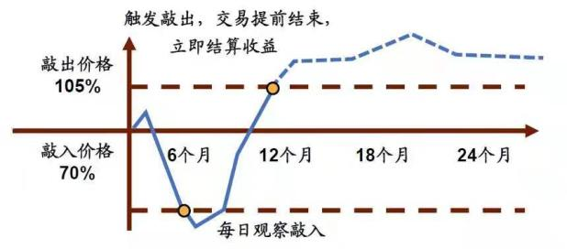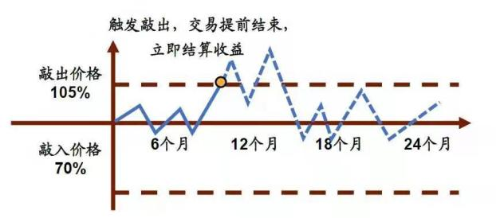

**2.2 The snowball products did not reach the knock-out condition during the contract term.**

In this case, the product may or may not hit a knock-in condition. When the knock-in condition is reached, the relative size of the opening and closing prices will also affect the investors' earnings. Therefore, the revenue is divided into three cases.

(1) When the knock-in condition is not reached during the contract term and the knock-out condition is not reached before the contract term expires, the investor gains the most, which is D*A/365 .

(2) When the knock-in condition is reached during the contract term and the underlying price on the contract expiry date is ≥ the opening price, the investor has no income at this time, which means the revenue is 0.

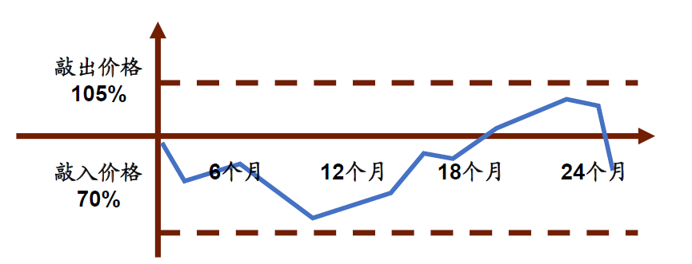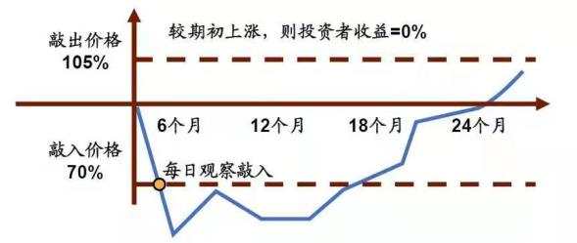

(3) When the knock-in condition is reached during the contract term and the underlying price on the contract expiry date is < the opening price, the investor has a negative gain, and the loss is "opening price-closing price".

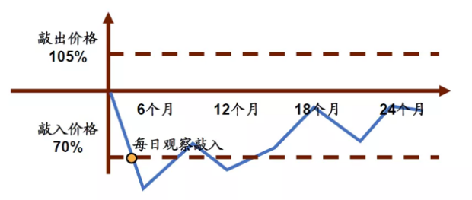

**Conclusion:**

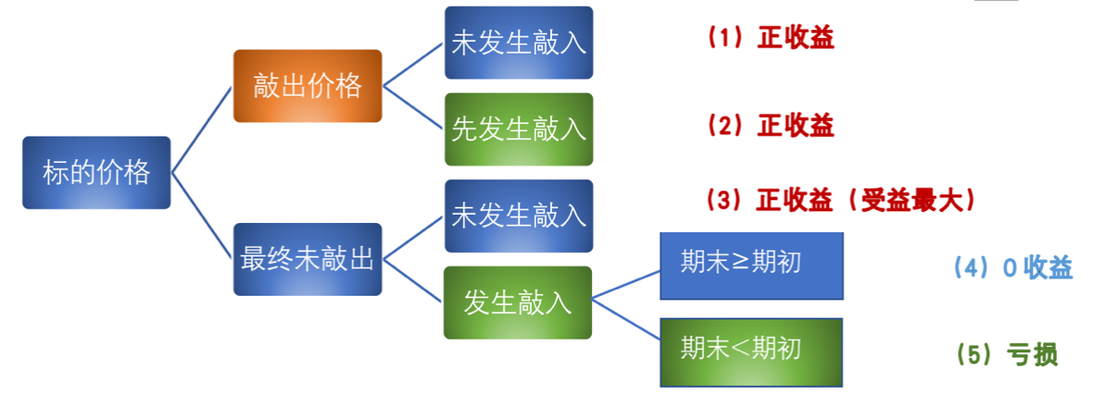

The explanation of the snowball products with the underlying price of CSI 500 is as follows:

|  |  |
| --- | --- |
| **The underlying price** | **CSI 500** |
| Observation period (product term) | Usually 12 months |
| Opening price (point on the opening observation date) | Set as 5000 points |
| Knock-in price (downside protection) | Set as 20%, which is 4000 points |
| Knock-in observation day | Every trading day |
| Knock-in event | The closing price of a trading day is lower than 4000 points. |
| Knock-out price | 5000 points |
| Knock-out observation day | Set as once a month |
| Knock-out event | The closing price of an observation day is higher than 5000 points |
| Post knock-out revenue | The performance basis is annualized as XX% |

From the table, we can see that the investors will gain profit if the snowball products with the underlying price of the CSI 500 on the observation date is higher than the opening price. As long as the downside does not exceed the downside protection range during the observation period, investors will not experience losses and will still be able to gain.

1. **Introduction to the advantage of snowball products**

From the analysis of the revenue structure, we can see that the advantage of snowball products is that it provides investors with a price fall protection for their investment products, which means even a slight price shock will not affect investors' revenue, and investors will only lose money if the price falls all the way to below the knock-in price. This kind of investment view is generally stated as “although we don't know whether the stock market can rise, we think that the probability of the stock market falling to the knock-in is small.”

## II Introduction and Principle of Monte Carlo Simulation

Monte Carlo simulation is a method to study the distribution characteristics by a stochastic process repeatedly generating time series, calculating parameter estimates and statistics. Based on the historical data or the parameter characteristics under the given distribution assumption, the method simulates a large amount of portfolio income data with the help of a random generation method, and then derives the value of VaR, which can better deal with nonlinear and non-normal problems without assuming that the risk factors belong to a specific distribution. Furthermore, the high-dimensional integration operation is simplified, and the time complexity of the algorithm involving the high-dimensional integration is reduced.

Generally speaking, Monte Carlo Simulation is to simulate a project to be implemented thousands of times on a computer, and the input value is randomly selected for each input. Since each input is an estimation interval in many cases, the computer model will randomly select any value of each input interval, and through a large number of simulations, the cumulative probability distribution map is finally obtained.

1. **Procedures of Monte Carlo simulation**

The procedures of Monte Carlo Simulation are shown in the following figure. First of all, we need to establish a model for the problem. The model should be consistent with the actual problem or system in terms of the main characteristic parameters. Then, according to the distribution of each random variable in the model, a random number is generated in calculation to realize a sufficient number of random numbers required for a simulation process. The larger the number of tests is, the larger the sample of dependent variable is.When the sample is large enough, the distribution of dependent variable can be approximately known.

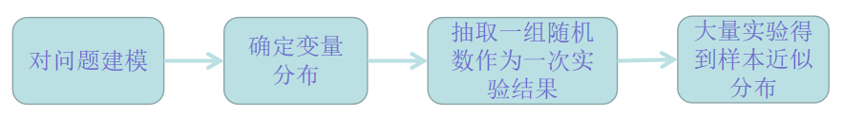

1. **Application of Monte Carlo Simulation in finance**

Since the 1970s, financial risks have been increasing continuously. The central idea of Monte Carlo method is the law of large numbers. When using this method, we need to set the data generation process of things and simulate the probability distribution of the development of things by combining random sampling. Therefore, for further analysis, Monte Carlo Simulation can roughly simulate the peak and heavy tail characteristic and fitting non-normality of the yield. Monte Carlo Simulation can be used to analyze the investment risks in the securities market, provide reference for investors, effectively control and reduce financial risks, consolidate the stability of the entire financial and economic system, and maintain the normal operation of microeconomic entities. It plays an active role in risk management and derivative pricing.

As there are many variables involved in snowball risk analysis, Monte Carlo Simulation is more suitable for risk analysis.

## Ⅲ Snowball Product Pricing and Revenue Measurement

1. **Determining parameters**

Our team designed a user interface with adjustable parameters. Before the simulation, the parameters that we can adjust include the test start time (YY-MM-DD), test end time (YY-MM-DD), knock-in and knock-out multiples, due duration (month), manually enterable volatility, closing price of the opening stock index, and the return on investment for cases 1,2 and 3 respectively .

Among them:

**(1) Test start time:** The simulation of the volatility calculation of CSI 500 closing price pathis expected to be used for the beginning of the interval. That is to say, if 2020-12-31 and 2021-04-21 is selected as the time interval, the volatility of that interval will be used to simulate the volatility rate of the closing price of the stock index in the next 2 months.

**(2) Test end time:** The beginning date of snowball product calculation.

**(3) Knock-out and knock-in multiples:** Modify the boundaries as specified for snowball products.

**(4) Due duration:** Counted by months.

**(5) Stock index price:** The closing price of the opening stock index.

**(6) Return on investment for cases 1, 2 and 3:** It can be modified according to the conditions specified by snowball products, and the format is to keep two decimals.

**(7) Volatility can be manually entered:** The volatility parameter can be modified so that it is no longer subject to the volatility within the time interval set out in the above column.

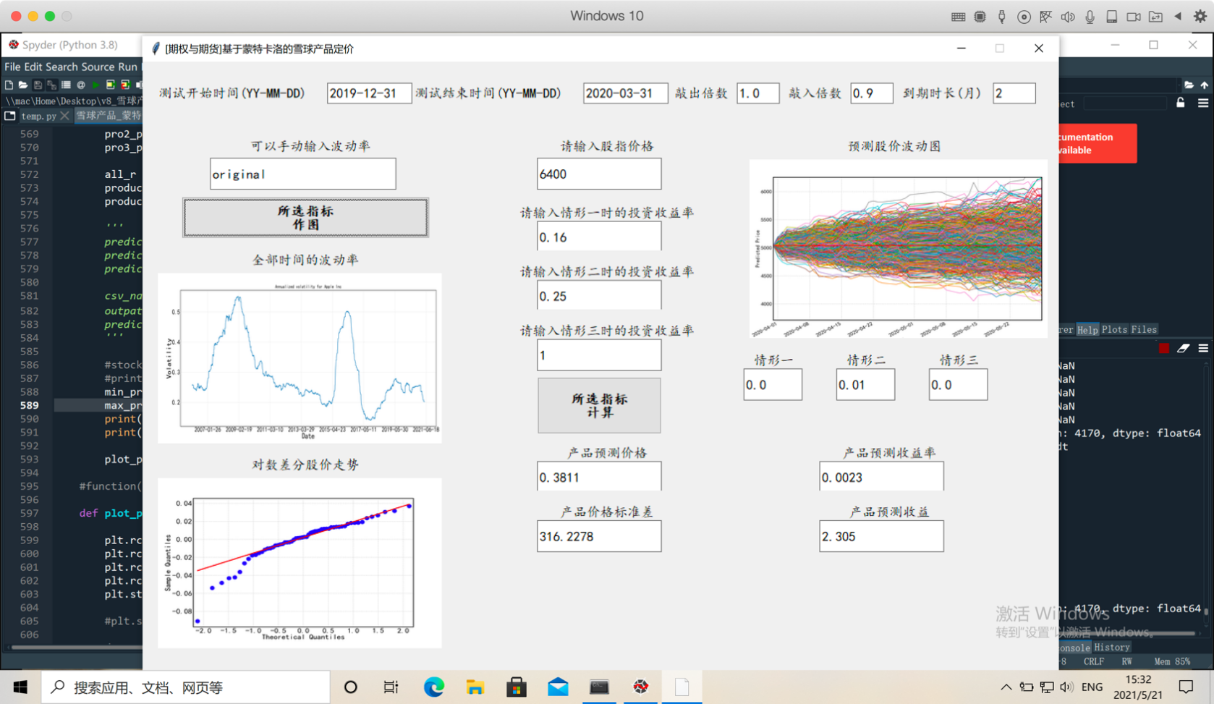

In the simulation, our team first selected 2020-12-31 to 2021-04-21 as the interval for volatility calculation. The volatility in this interval is about 0.09. From the daily annualized volatility since the establishment of the CSI 500, estimated by the moving average model (MA), this period is much more stable than the historical market shock period (i.e. 2008 financial crisis and 2016 stock market shock).

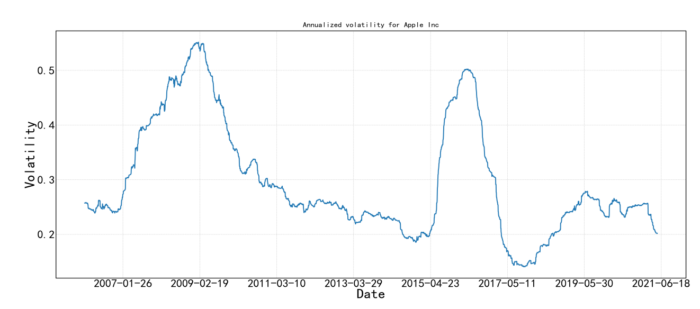

On this basis, our team used Monte Carlo Simulation to simulate **100000** stock index price items for two snowball products.

**1.1 Product 2-"Star Sea".**

1. Opening price: Select the closing price of the CSI 500 on 2021-04-21, which is 6420.26 yuan.
2. Revenue observation date: The product term is 2 months, and the 11th day of each month on the commencement date is the revenue observation date.
3. Expected yield:

|  |  |  |
| --- | --- | --- |
| **Situation** | **Detailed description** | **Return on investment** |
| Case 1 | Knock-out events occurred on 2 revenue observation days | 16% |
| Case 2 | There was no knock-out or no knock-in event on 2 revenue observation days | 25% |
| Case 3 | There was no knock-out event but knock-in occurred on 2 revenue observation days. | -max(0,  float(s[0])-float(s[k]))/float(s[0]) |

1. Knock-in and knock-out conditions:

|  |  |  |
| --- | --- | --- |
| **Situation** | **Observation time** | **Condition** |
| Knock-in condition | Last revenue observation date and any previous trading day | The closing price of the relevant underlying price is less than 90% of the opening price |
| Knock-out condition | Knock-out observation day | The closing price of the relevant observation price is more than or equal to the opening price *100% |

(5) Volatility: Calculated by using historical data from 2020-12-31 to 2021-04-21. Volatility can also be entered manually.

**1.2 Product 1—"Light of Hope".**

(1) Opening price: Select the closing price of the CSI 500 on 2021-04-21, which is 6420.26 yuan.

(2) Revenue observation date: The product term is 2 months, and the 11th day of each month on the commencement date is the revenue observation date.

(3) Expected yield:

|  |  |  |
| --- | --- | --- |
| **Situation** | **specify** | **rate of return** |
| Case 1 | Knock-out events occurred on 2 revenue observation days | 4% |
| Case 2 | There was no knock-out or knock-in event on 2 revenue observation days | 4% |
| Case 3 | There was no knock-out event but knock-in occurred on 2 revenue observation days | -max(0,  float(s[0])-float(s[k]))/float(s[0]) |

(4) Knock-in and knock-out conditions:

|  |  |  |
| --- | --- | --- |
| **Situation** | **Observation time** | **Condition** |
| Knock-in condition | Last revenue observation date and any previous trading day | The closing price of the relevant underlying price is less than 85% of the opening price. |
| Knock-out condition | Knock-out observation day | The closing price of the relevant underlying price is more than or equal to the opening price *100% |

(5) Volatility: Calculated by using historical data from 2020-12-31 to 2021-04-21. Volatility can also be entered manually.

1. **Simulation of stock index price based on Monte Carlo**

**2.1 Train of thought**

The theoretical basis of Monte Carlo Simulation is the risk-neutral pricing principle, which, by simulating the underlying asset price path and predicting the average return of an option, forecasts the price. Under risk neutrality, we simulate the price of a risky asset by a random path from the initial moment to the due date, calculate the return to maturity under this path, and discount the return based on the risk-free interest rate. Repeating this process will result in a large number of random samples of discounted returns, and the Monte Carlo Simulation can be obtained by averaging the samples.

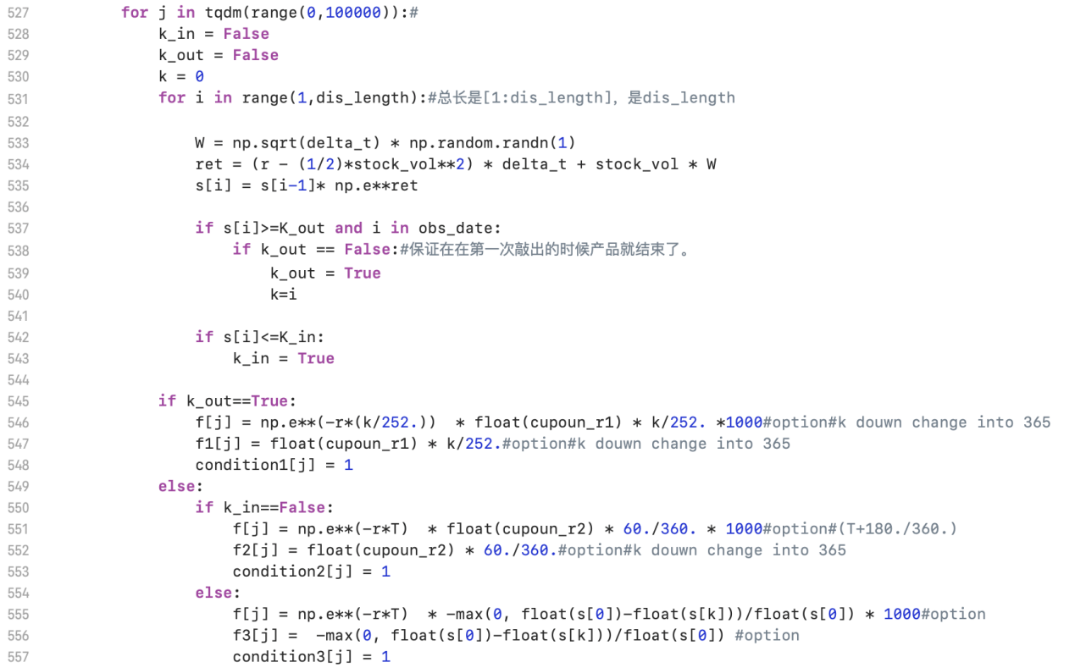

In the whole simulated stock index closing price path, the starting point of the path, which is the closing price at the opening date, is known. According to the following formula, 100000 stock index closing price paths can be simulated.

$$s\left[i\right]=s\left[i-1\right]*e^{\left(r-\frac{1}{2}σ^{2}\right)∆t+σε\sqrt{∆t}}$$

In which, r is the risk-free interest rate, $σ$ is the volatility, and $∆t$ is the product term/total trading days. $ε$ is a random number of normal distribution.

**2.2 Parameter adjustment**

In this report, in addition to the normal return rate, we also simulated the stock price with high and low volatility parameters. We simulated the price trend of 100000 CSI 500 items in the next two months under the two volatility conditions of high volatility (33%) and low volatility (4%), and the results are shown in the following two charts.

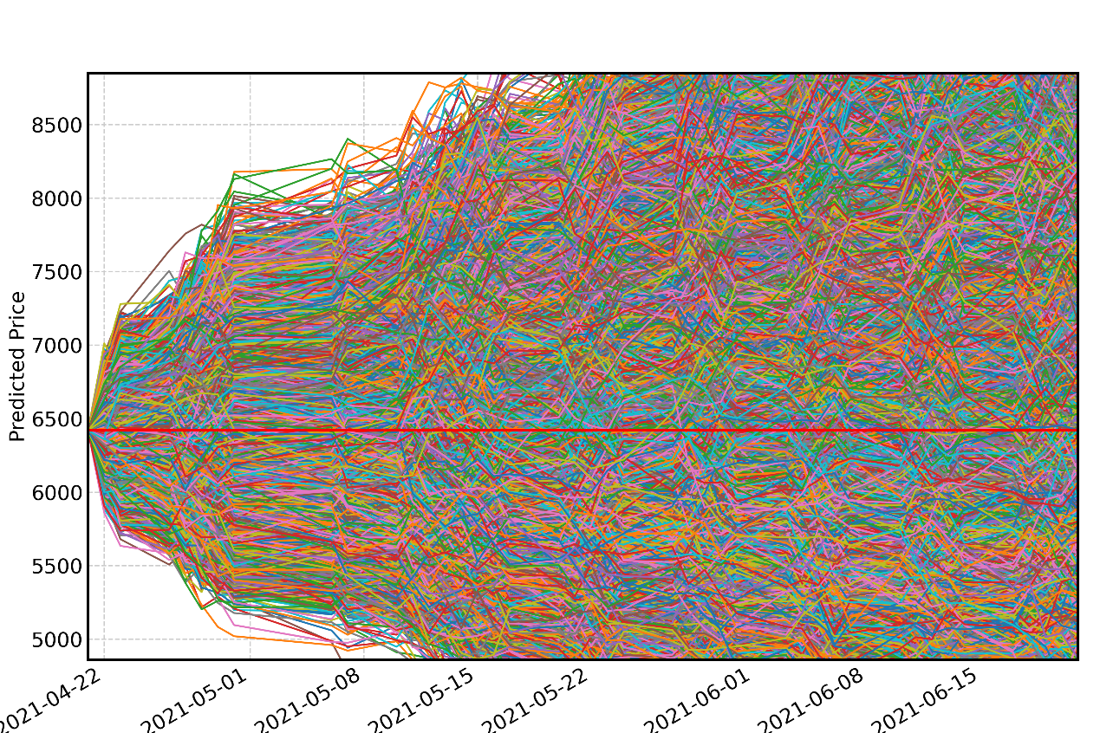

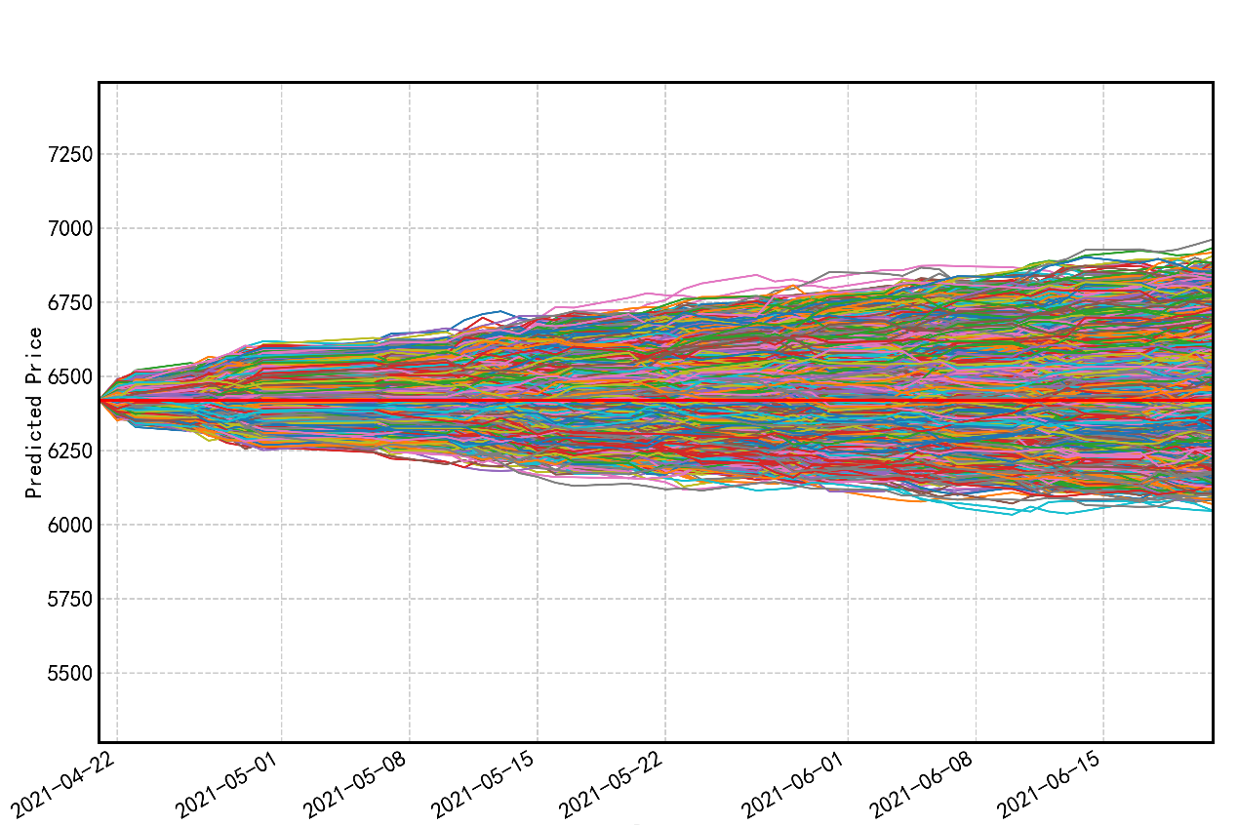

In the above price simulation charts:

(1) Under the high volatility parameter, the price of the CSI 500 after 2 months is as high as 8241.53 yuan and as low as 4810.37 yuan.

(2) Under the low volatility parameter, the price of the CSI 500 after 2 months is as high as 7566.26 yuan and as low as 5344.30 yuan. It can be observed that the larger the volatility parameter, the larger the range of future stock price volatility.

1. **Snowball option pricing**

The two snowball products in this report are both structured derivatives based on the underlying price of the CSI 500, which can be regarded as the combined income consisting of two components, namely "fixed income" and "put option". We simulated the future 100000 price paths of the snowball underlying stock through Monte Carlo, and calculated the final revenue of snowball products under various price paths. Through these simulation results, the reasonable pricing, benefits and risks of snowball products are analyzed.

If a knock-out occurs:

$${Revenue}_{con1}=e^{-r*\frac{k}{252}}*return_{con1}*\frac{k}{252}*principal$$

If no knock-out or knock-in occurs:

$${Revenue}_{con2}=e^{-r*T}*return_{con2}*\frac{60}{360}*principal$$

If no knock-out occurs but a knock-in occurs:

$${Revunue}_{con3}=e^{-r*T}*\left[-\frac{\max\left(0,Opening price-Closing price\right)}{Opening price}\right]*principal$$

Through Monte Carlo Simulation, we got the revenue of each case corresponding to 100000 stock index paths under high, medium and low volatility levels, and got the forecasted yield and price of the products.

1. **Revenue measurement of snowball products**

**4.1 Overall expected yield**

Through 100,000 times of stock index closing price path simulation, the probability of three cases can be calculated. From this, the expected value of the overall yield can be calculated:

$$E\left(return\right)={Pro}_{1}*return_{con1}+{Pro}_{2}*return_{con2}+{Pro}_{3}*return_{con3}$$

**4.2 Fair Return on snowball products**

Under the risk-neutral measure, the reasonable price of the snowball products is the expected discounted value of the return at maturity, which is the return at the level of fair return. By calculating the average return rates of three cases in 100,000 simulations respectively, the fair return rates of each snowball product in each case can be obtained:

$$E\left({return}_{j}\right)=\frac{\sum_{i}^{100000}{{return}_{conj,i}}}{n_{conj}}, j=1,2,3$$

There are three kinds of returns based on snowball products: knock-out, no knock-out or knock-in, and knock-in but no knock-out. In the first two cases, investors receive fixed income. Among them, knock-out and knock-in prices have a direct impact on the pricing and earnings of brokers and investors, and are crucial in the pricing of snowball products. Take "Star Sea" as an example, under a given contract, for every percentage point change in knock-in and knock-out prices, the revenue will change by three to four times. At the same time, when the volatility is 0, the revenue is 16% of the agreed coupon, but the corresponding revenue decreases as the volatility increases.

For the "Star Sea", Case 1: Once a knock-out occurs, the fair return is 4.17%, and the positive return rate is far lower than the coupon rate. Case 2: The yield of 25% is derived from "no knock-out or knock-in", which means the underlying price is not higher or lower than the knock-in price. Its fair return is 1.21%. Case 3: Knock-in occurs but no knock-out. A larger loss under fair return with a small probability may happen.

For the "Light of Hope", Case 1: Once a knock-out occurs, the fair return is 0.30%, and the positive return rate is much lower than the coupon rate. Case 2: The yield of 4% is derived from "no knock-out or knock-in", which means the underlying price is not higher or lower than the knock-in price. Its fair return is 0.67%. Case 3: Knock-in occurs but no knock-out. A larger loss under fair return with a small probability may happen.

The product yield rate is the expected yield rate obtained by multiplying the probability and the yield in three cases. The price of the product is the discounted value of the expected excess return at fair rate of return.

## IV Analysis on the Final Revenue and Risks of Snowball Products under Different Simulation Paths

We compared and analyzed the final revenue of the two snowball products under different volatility parameters based on the 100000 different price paths in the next 2 months. In this report, we set two volatility parameters, high and low, to simulate the volatility of 0.099 from 2020-12-31 to 2021-04-21. The results are shown as follows:

1. **Revenue and risks when only volatility changes**

**1.1 “Light of Hope”**

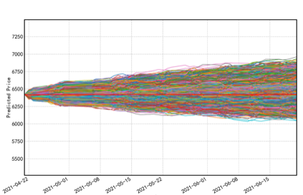 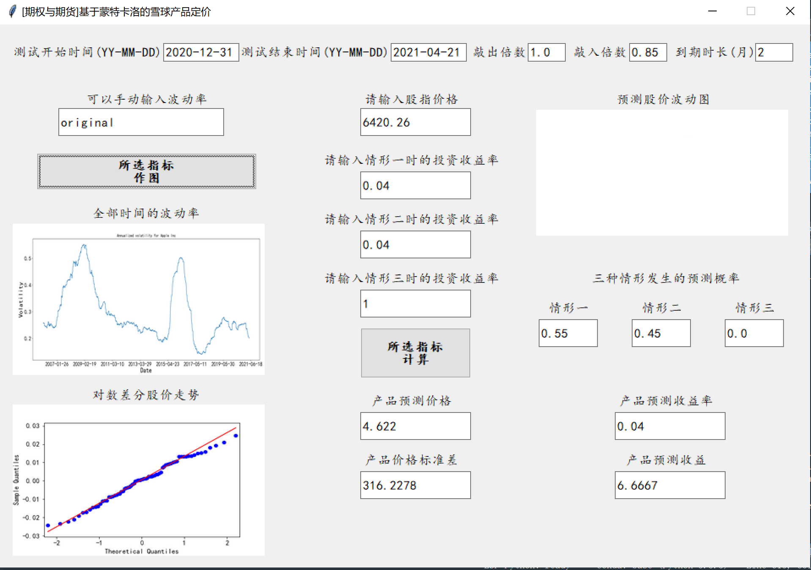

The above figure shows the product price and yield forecast of "Light of Hope" under normal volatility. Under this setting, the probability of occurrence of Case 1 and Case 2 are similar, and the probability of Case 1 is relatively higher. The occurrence probability of Case 3 is 0, which means no knock-in, so the investor obtains 4% of the investment income and the product price is 4.63 yuan.

|  |  |  |  |  |  |
| --- | --- | --- | --- | --- | --- |
|  | **Case 1 probability** | **Case 2 probability** | **Case 3 probability** | **Forecast yield on products** | **Forecast price of products** |
| **Low volatility (0.04)** | 0.63 | 0.37 | 0.00 | 4.0% | 4.34 |
| **Normal volatility (0.099)** | 0.55 | 0.45 | 0.00 | 4.0% | 4.63 |
| **High volatility (0.33)** | 0.50 | 0.32 | 0.18 | 3.3% | 3.60 |

The table above shows the forecast of product prices and yield for the three volatility settings. It can be found that the probability of occurrence of Case 1 is the highest and the probability of occurrence of Case 3 is the lowest under all three settings. Among them, the probability of occurrence of Case 3 is non-zero only under the high volatility setting, and there is a knock-in risk.

**Conclusion:**

(1) If the volatility is very low, and in extreme cases the volatility is 0, it will always be in a state of no knock-out or knock-in, and the overall revenue will approach 4%.

(2) If the volatility is appropriate, we can conclude that it is more likely to fluctuate within a relatively narrow range, then its yield may be a weighted sum of 4% (knock-out) and 4% (nothing) in some way.

(3) If the volatility is too large, it is possible that a knock-in will occur and investors are exposed to risk of loss.

**1.2 “Star Sea”**

The following figure shows the product price and yield forecast of "Star Sea" under normal volatility. Under this setting, the occurrence probability of Case 1 and Case 2 are similar, and the probability of Case 1 is relatively higher. The probability of occurrence of Case 3 is 0, which means no knock-in, so the investment income may be 16% or 25%, of which the probability of 16% is relatively higher, and the product price is forecasted to be 25.01 yuan.

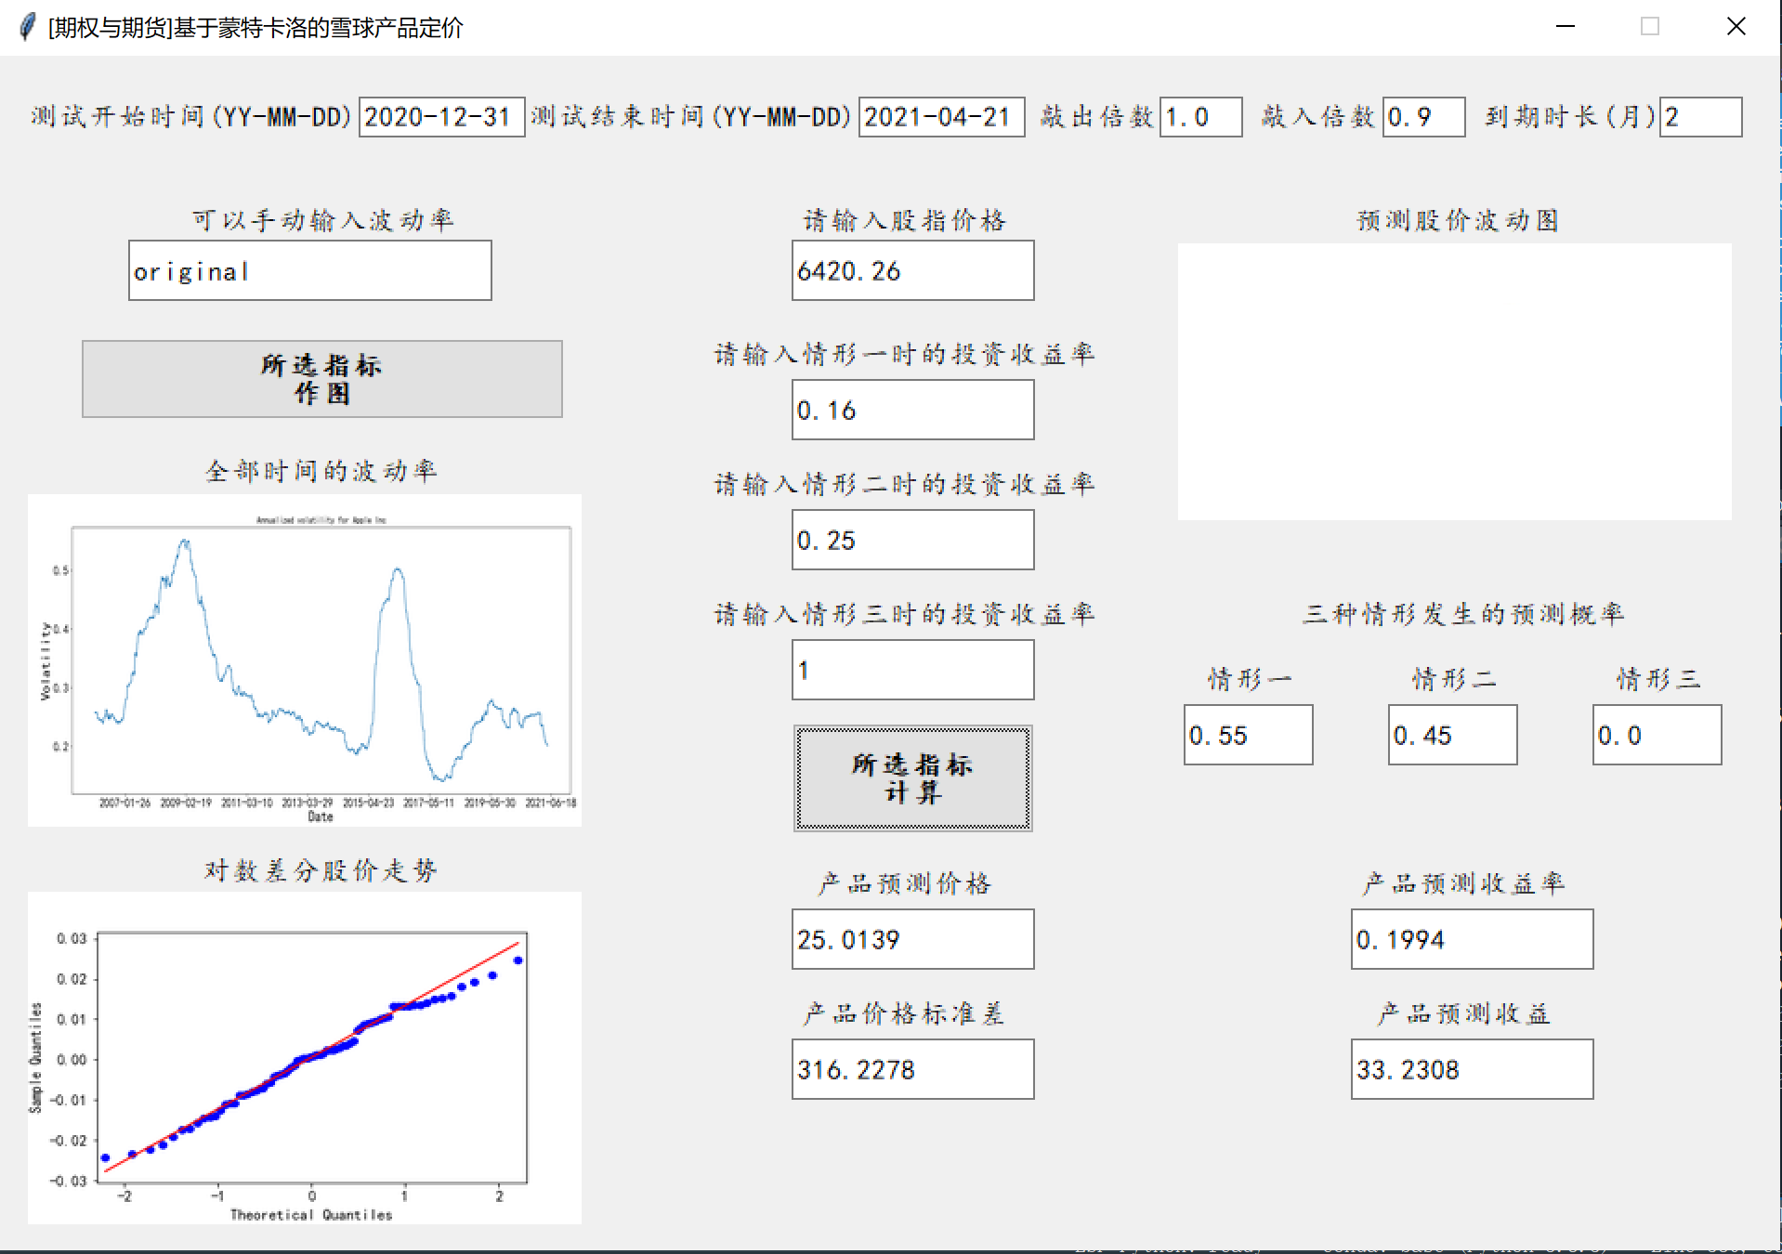

|  |  |  |  |  |  |  |
| --- | --- | --- | --- | --- | --- | --- |
|  | **Scenario one probability** | **Case 2 probability** | **Case 3 probability** | **Forecast yield on products** | | **Forecast price of products** |
| **Low volatility (0.04)** | 0.63 | 0.37 | 0.00 | | 19.32% | 22.83 |
| **Normal volatility (0.099)** | 0.55 | 0.45 | 0.00 | | 19.94% | 25.01 |
| **High volatility (0.33)** | 0.50 | 0.16 | 0.34 | | 12.04% | 12.69 |

It can be found that the yield under normal volatility (0.099) is slightly higher than that under low volatility (0.04), which is contrary to the absolute common sense that the yield is higher under low volatility.

**Conclusion:**

(1) The lower the volatility, the higher the yield, indicating a high probability of events, but there are exceptions.

(2) It can be imagined that a stock index price path with extremely low volatility (assuming that volatility is 0) is very close to the opening stock index price, which is very prone for knock-out events to occur. On the contrary, if a stock index with appropriate and not too low volatility falls below the opening price limit and shocks within the range above the knock-in price, the probability of knock-out events is smaller than that of the former, and knock-out does not occur, then the snowball product underlying price based at this stock index may generate more revenue.

(3) If the volatility is appropriate, we can assume that it shocks within a narrow range, then its yield may be a weighted sum of 16% and 25% in some way.

(4) If the volatility is too high, it is possible that a knock-in may happen and investors are exposed to the risk of loss.

1. **Revenue and risks when only knock-out price changes**

**Take the “Star Sea” as an example.**

The following figure shows the product price and yield forecast of "Star Sea" when the knock-out multiple is 1.02. Under this setting, the probability of occurrence of Case 2 is now significantly greater than that of Case 1. The probability of occurrence of Case 3 is 0, which means no knock-in, so the investment revenue may be 16% or 25%, of which the probability of 25% is relatively higher, and the product price is forecasted to be 33.16 yuan.

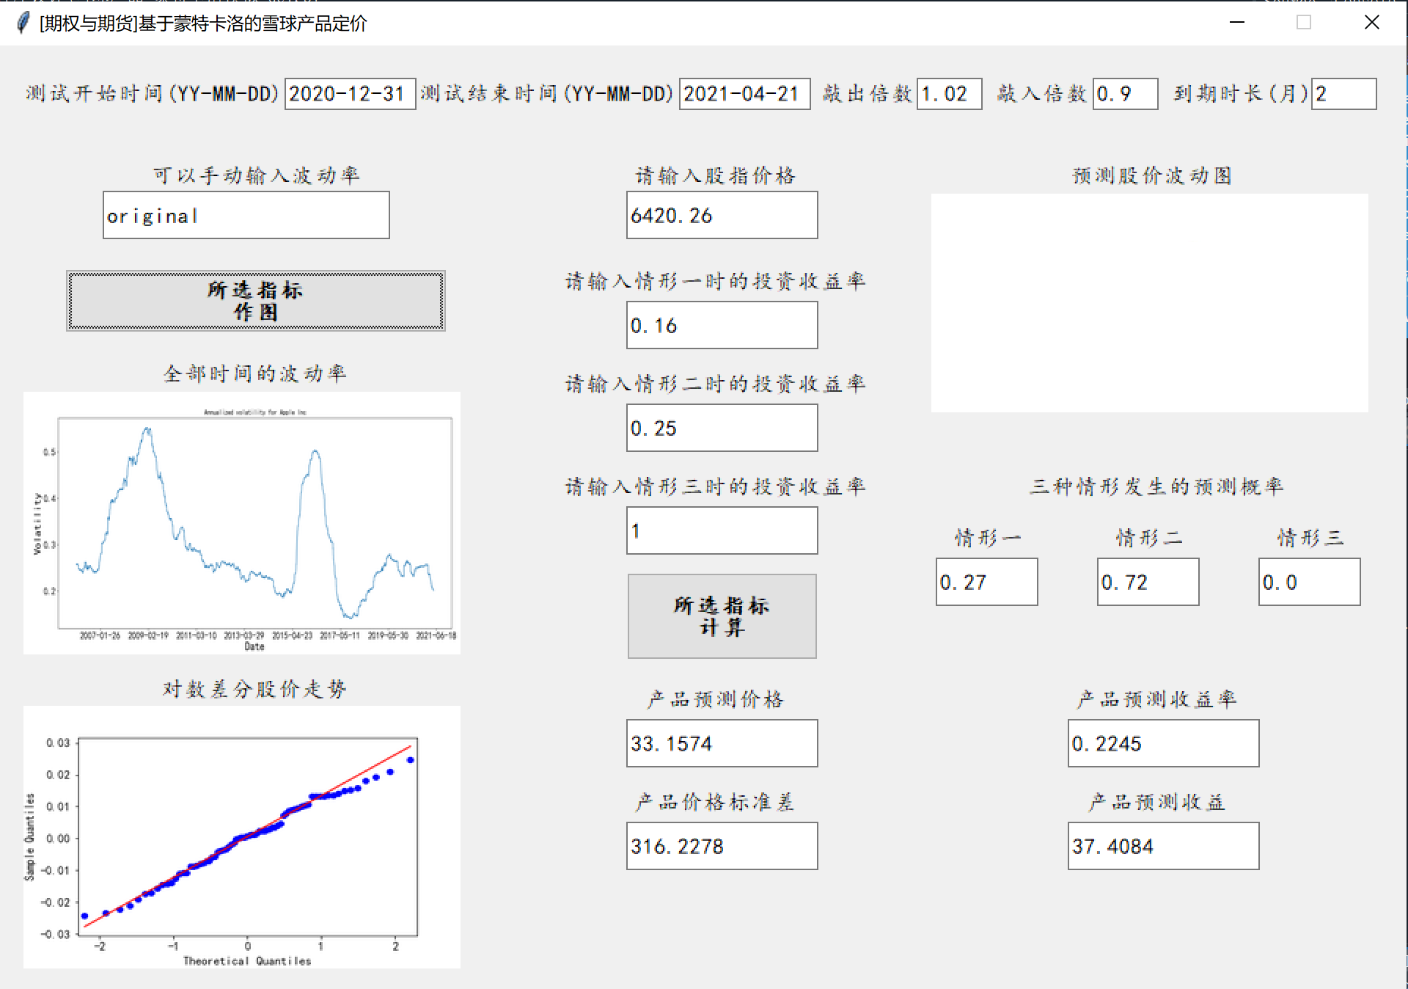

|  |  |  |  |  |  |  |
| --- | --- | --- | --- | --- | --- | --- |
|  | **Case 1**  **probability** | **Case 2 probability** | **Case 3 probability** | **Forecast yield on products** | | **Forecast price of products** |
| **1.00 knock-out price** | 0.63 | 0.37 | 0.00 | | 19.32% | 22.83 |
| **1.02 knock-out price** | 0.27 | 0.72 | 0.00 | | 22.45% | 33.16 |
| **1.04 knock-out price** | 0.09 | 0.91 | 0.00 | | 24.05% | 38.38 |

**Conclusion:**

(1) The higher the knock-out price, the higher the probability of the occurrence of Case 2, which greatly occupies the space for the occurrence of Cases 1 and 3.

(2) The higher the knock-out price, the higher the price of snowball products.

(3) The higher the knock-out price, the higher the forecast yield rate of snowball products.

1. **Revenue and risks when only knock-in price changes**

**Take the “Star Sea” as an example.**

The following figure shows the product price and yield forecast of "Star Sea" when the knock-out multiple is 0.80. Under this setting, the probability of occurrence of Case 2 and Case 1 are still relatively close, and there is no obvious change. The probability of occurrence of Case 3 is 0.

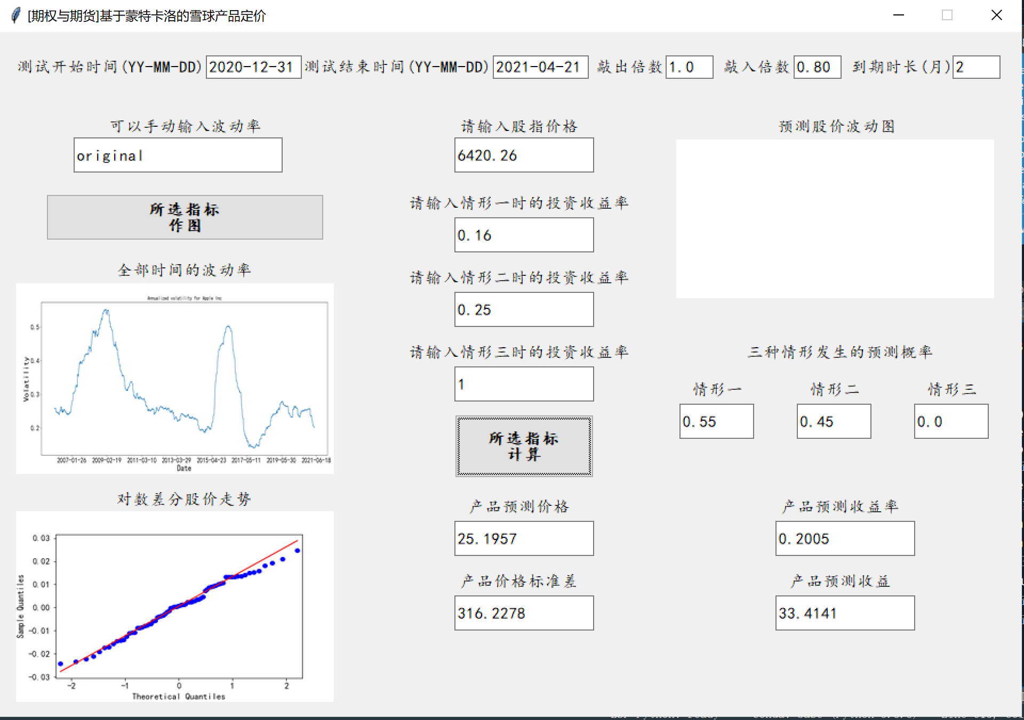

|  |  |  |  |  |  |  |
| --- | --- | --- | --- | --- | --- | --- |
|  | **Case 1 probability** | **Case 2 probability** | **Case 3 probability** | | **Forecast yield on products** | **Forecast price of products** |
| **0.90 knock-in price** | 0.55 | 0.45 | 0.00 | 19.94% | | 25.01 |
| **0.80 knock-in price** | 0.55 | 0.45 | 0.00 | 20.05% | | 25.20 |
| **0.70 knock-in price** | 0.55 | 0.45 | 0.00 | 20.06% | | 25.26 |

**Conclusion:**

(1) The lower the knock-in price, the higher the probability of occurrence of Case 2, slightly crowding out the space for occurrences of Case 1 and 3.

(2) The lower the knock-in price, the higher the price of snowball products.

(3) The lower the knock-in price, the higher the forecast yield of snowball products.

## Ⅴ Conclusion of Experimental Simulation

**Conclusion 1— Under the three volatility parameters, Case 1 has the highest probability of occurrence, Case 2 is the second highest, and Case 3 has the lowest probability of occurrence.**

If, under the normal volatility simulation, the probability in Case 1 (knock-out occurs, and termination in advance) for both products is 55%. Under the low volatility simulation, the probability of Case 1 is 63%. Case 3 is a knock-in scenario during the contract term, and under the three different volatility simulations, the probability of occurrence is extremely small and almost unlikely to happen. This has much to do with the length of the contract term and how high the knock-in and knock-out price are.

It should be noted that the order of probability of occurrence of cases 1, 2 and 3 depends on not only simulation but also different knock-in and knock-out price settings. Taking the high volatility simulation as an example, the probability of occurrence of "Light of Hope" Case 2 and Case 3 is 32% and 18% respectively, while that of "Star Sea" is 17% and 34% respectively. It can be inferred that the knock-in risk of "Star Sea" in high volatility is much higher than that of "Light of Hope".

**Conclusion 2—The probability of occurrence of Case 3 gradually increases with the increase of volatility.**

In Case 3, the investor will face a loss if the knock-in occurs but the knock-out did not before the due date. In a setting of higher volatility, prices may fall more, causing investors to incur greater losses. As a result, the biggest loss on buying snowball products may be magnified if investors predict that market volatility will increase in the future.

**Conclusion 3-The lower the volatility, the higher the product yield.**

If the volatility is very low, and in extreme cases the volatility is 0, it will always be in a state of no knock-out or knock-in, and the overall revenue will approach 4%. With the increase in volatility, there is a possibility of knock-in and investors are exposed to the risk of loss.

**Conclusion 4—The higher (lower) the knock-out (in) price is, the higher the probability of occurrence, product price and yield of Case 2 is.**

The higher (lower) the knock-out (in) price is, the more room is given for the stock index closing price to fluctuate, so that even if the stock index price path with higher volatility is still neither knock-out nor knock-in, in the second state of the highest return on investment. The probability of a knock-in event is significantly reduced. Therefore, the higher the price and yield of the products.

**Conclusion 5—With the increase of knock-out price and the decrease of knock-in price, the marginal rate of increase in product price and yield decreases.**

The experimental results show that when the knock-out (in) price increases (decreases) from 1 as the origin to the increases (decreases) to the top (bottom) in equal difference, the increase in product price and rate of return significantly slows down. When it comes to1 $∓0.2$, there is hardly any significant change in result.

## VI Snowball Products and Quota Selection

1. **Revenue and risk comparison between "Light of Hope"/" Sea of Stars"**

|  |  |  |  |  |
| --- | --- | --- | --- | --- |
|  |  | **Low volatility (0.04)** | **Normal volatility (0.099)** | **High volatility (0.33)** |
| **Light of Hope** | **Expected yield** | **4.00%** | **4.00%** | **3.30%** |
| **Standard deviation of yield** | **9.23%** | **10.34%** | **12.56%** |
| **Star Sea** | **Expected yield** | **19.32%** | **19.94%** | **12.04%** |
| **Standard deviation of yield** | **23.31%** | **24.59%** | **27.63%** |

As can be observed from the above table, the expected yield of "Star Sea" is higher than the "Light of Hope" under all three volatility conditions, but it is consistent with the characteristics of "high risk and high return". The standard deviation of its yield is also higher than the "Light of Hope". Considering the recent trend of the CSI 500, our team judged that it is more likely that a knock-out will occur on the observation day, and therefore we chose to purchase the "Star Sea".

1. **Quota selection: 1000 yuan**

From the calculation results, we know that the expected yield of the two snowball products are positive under all three volatility conditions, so we should purchase the maximum amount to maximize the expected revenue. In addition, even considering the occurrence of Case 3 (knock-in but no knock-out), in a strong volatility market with volatility set at 33%, the expected yield of Case 3 is 0, and no material loss has occurred, so the loss probability is almost close to 0 .

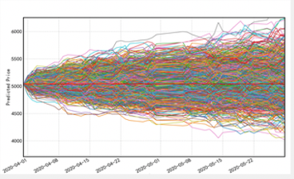

According to the calculation result of "Star Sea", when the purchase quota is 1000 yuan, the revenue of our team is forecast to be 33.23 yuan.

## Ⅶ Algorithm Optimization

1. **Optimization of random generation sequences**

In the Monte Carlo Simulation, the uniformity of the random number sequence will have a great impact on the results. Unstable random number sequence may lead to larger errors in the experiment. Therefore, the problem can be better remedied by using low deviation sequence. We used Faure sequence, Halton sequence and Sobol sequence respectively to replace the original random number sequence.

1. **Optimization of parallel For loop**

When the simulation is done for many times, for example, when the number of simulations performed by our team is 100,000, it usually takes 10-20 minutes to run the code once, which is very unfavorable for experiments and research. The reason is that the speed of single for loop is too slow. Therefore, the .process() function is used to modify the single for loop to the parallel for loop in order to improve the running speed.

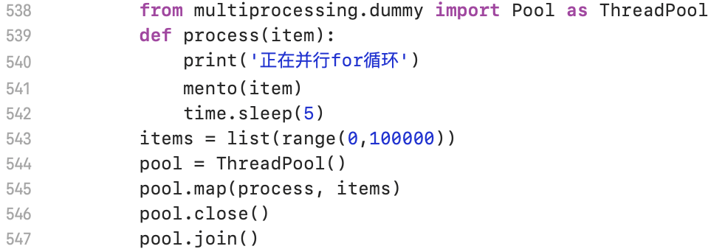

The operating speed is reduced from 15 minutes to about 8 minutes.

## VIII Conclusion and Prospects

1. **The greater the volatility of the underlying price, the less the investor is likely to receive.**

After analyzing the three kinds of volatility, we can see that low volatility increases the probability of knock-out and favors the first kind of revenue, while the revenue under normal volatility are weighted by different circumstances. We usually choose the object with small fluctuations in the future.

1. **The longer the product term, the lower the coupon rate.**

The longer the product term, the higher the probability of a product being knocked out, and the higher the probability that an investor will ultimately receive a positive return, but the lower the coupon rate during the contract term of the snowball product.

1. **The lower the knock-out and knock-in prices, the greater the probability that investors will receive a positive return.**

The lower the knock-out price, the higher the probability of early knock-out and the less likely the investors will get the full coupon. Generally, the lower knock-in price and the higher knock-out price are chosen, so that the investor can hold the contract till the due date and obtain the full coupon income.

1. **Snowball products can usually achieve expected high returns.**

Of the five revenue structures divided according to whether they are knocked out during the contract term, only when "knock-in occurred but knock-out never occurred” happens and the price of the subject matter at maturity is lower than the exercise price will the investor uses the "opening price-closing price" as their loss. Therefore, the snowball product usually can usually achieve the expected high revenue.